# **Talk Networks to Me 😉**

**Zoe's avatar**

[Zoe](https://substack.com/@zoeffc)

Jun 28, 2024

Share

Hi friends!

This is a long one because I am letting myself ramble about one of my favorite professional topics: networks! Buckle up, buttercup!

Plus — I did the scary thing and posted about this project on LinkedIn so now there are a few more people reading this. It felt thematically appropriate for the week. Welcome to the Cooperative!

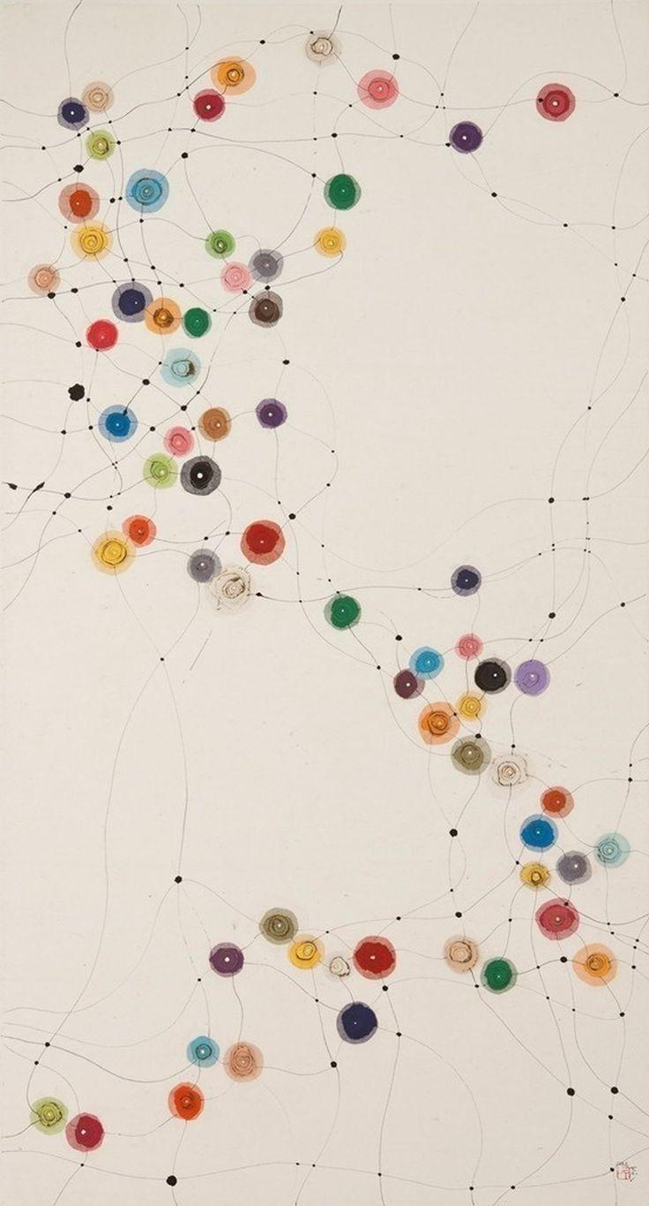

*It’s a network! Get it?*

First some housekeeping:

📫 If a friend forwarded you this newsletter (then you have some really cool friends), and you may want to consider joining us [*here*](https://femme-futures.beehiiv.com/subscribe) for regular updates.

🧲 Got some thoughts you want to share? Join us on [*Discord*](https://discord.gg/MgcQvRW2?utm_source=femme-futures.beehiiv.com&utm_medium=referral&utm_campaign=talk-networks-to-me) to chat all things newsletter and corporate life.

I came across a quote the other day that said something to the effect of “Don’t cultivate networks, cultivate friendships” and that is something I wish that I had learned earlier.

As a college senior I got a bee in my bonnet about networking in order to land a job post graduation. After a visit to the career center, where I was told that my best move was to reach out to at least ten alumni in my desired field and schedule conversations with as many as responded to me, I went ahead and did just that. I ended up spending most of my senior fall on zoom calls with people who had titles that interested me and then whoever they referred me to. Look at me go! I was a networking queen! By February of that year, I had lined up an internship that would turn into my first job post-graduation!

You would think that with that success, I would keep up the habit, but I didn’t. Most of the people that I talked with that fall, I haven’t even kept up with on LinkedIn. One of the people that I talked to works for the same institution as I do and we haven’t interacted as long as I’ve been in this job! Instead, I sit with the guilt of feeling like all of these people gave me an hour of their time, their knowledge, and their networks, only for me to disappear without a word. If I had successfully built a network with those conversations, I would have people in my industry that I talk to regularly because of it.

The funny thing is that I DO have a network! There are a ton of people celebrating my successes, commiserating with me, and keeping their eye out for opportunities that I might enjoy. This network came about naturally, through the connections and friendships that I made at work, at events, and in my personal life.

My family talks a lot about pretty-privilege (how life is easier for those who meet societal beauty standards). I think that another privilege to consider is the payoff of being pleasant.* I have been amazed at how my community turns-up for me when I need it — but I will give myself the credit of acknowledging that they turn-up for me because I turn-up for them. Just today my neighbor offered to let me stay in the flat that they are renting in NYC while I am there for the weekend — I am watching his cats sporadically as he travels this summer. My former hiring manager put me in touch with her best friend who is now a vital part of my network. The reverse is true as well — if you move through the world with combat and aggression as your first instinct, then that is how you will be met.

When it comes to networking, your friends are the ones who will be in your corner. This is one of the areas of life where quality matters over quantity. So go forth and be friendly!

Best,

Zoe

*I want to recognize that this doesn’t apply at all equitably across race, class, ability, gender, etc. I think that being nice will make everyone’s life easier, but privileges are stacked, and if you started with a shorter stack, nice-ness is not going to close that gap.

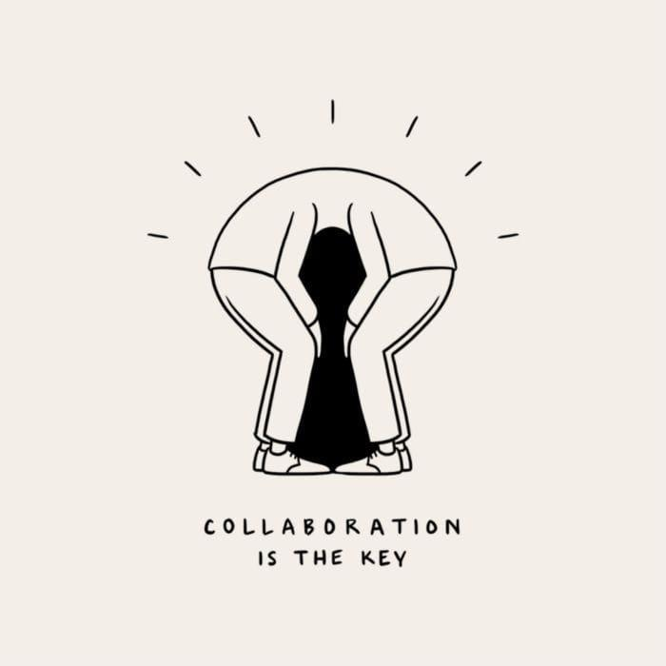

📌 **Next steps**

1. Add your friends on LinkedIn if you haven’t already!
2. Reach-out to an old work friend and ask how they are doing. (Do NOT make this a request!)
3. Reach out to a mentor and thank them for supporting you and how you see that impacting your life today.
4. Tell your friends about this little community by forwarding them this week’s newsletter

📓 Resources:

* I came across this talk some months ago and found it insightful for navigating workplace dynamics: [*https://www.youtube.com/watch?v=fHT35-zbtok&ab_channel=SXSW*](https://www.youtube.com/watch?v=fHT35-zbtok&ab_channel=SXSW&utm_source=femme-futures.beehiiv.com&utm_medium=referral&utm_campaign=talk-networks-to-me)

**Femme Futures Cooperative Founding Principles**

💚 **Mission**: The mission of Femme Futures is to create a community space for young professionals who identify as over-achievers and activists to generate collective success by providing resources and platforms to thrive in challenging workplace environments.

💙 **Vision**: To contribute to a world where driven individuals are equipped with the tools, guidance, and connections to overcome systemic barriers, fully utilize their talents, and enact positive change in their organizations and communities.